EAE 129 Final Project Report

**Simulation and Analysis of Aircraft Response Characteristics**

Analysis of Dynamic Response Characteristics and Flying Qualities

Aurian Malhotra

March 21, 2025

**Abstract**

This report analyzes the longitudinal dynamic response and stability of an aircraft using wind tunnel data to estimate aerodynamic derivatives. By constructing the **Longitudinal Linearized Equations of Motion in State-Space Form**, I determined the **A and B matrices (page 4)**, which provided insight into the aircraft's modal characteristics. Eigenvalue analysis revealed the presence of two primary longitudinal modes: **short-period and phugoid**. The short-period mode exhibited a high damping frequency, settling within seconds, while the phugoid mode was lightly damped, leading to prolonged oscillations.

Time response analysis was conducted under two conditions: **zero input with initial pitch disturbance** and **unit step elevator deflection (pages 7-8)**. In the zero-input scenario, the short-period mode dissipated quickly, while the phugoid mode persisted longer before stabilizing. Under a unit step input, the short-period mode dominated the immediate response, while the phugoid mode influenced long-term behavior. These responses align with expected aircraft behavior and confirm the aircraft is **dynamically stable** since all real parts of the eigenvalues are negative.

Using modal characteristics and **handling quality criteria**, I classified the aircraft as **Class IV, Category B, Level 1**, indicating it is a high-maneuverability aircraft with optimal handling qualities for nonterminal flight phases. The aircraft meets stability and control requirements, requiring minimal pilot workload.

**Introduction**

Understanding the dynamic response characteristics of an aircraft is crucial in aerospace engineering, as it directly affects the vehicle’s safety, performance, and maneuverability. Aircraft stability refers to its ability to return to equilibrium after a disturbance. In this report, I will analyze wind tunnel data to estimate longitudinal derivatives which in turn will allow me to determine key characteristics to describe the dynamic response of our aircraft. With aerodynamic data and stability derivatives, I aim to assess the characteristic roots of the system which will allow me to analyze the time response, its properties, dynamic stability, and handling quality.

**Equation (1):**

**Equation (2):**

**Equation (3):**

**Equation (4):**

**Equations (1) – (4)** will allow us to determine the modal characteristics of the system. This will provide us with information about the stability of our aircraft as well as the oscillation trends and frequency of the time response.

For our experiment, we also require the **Longitudinal Linearized Equation of Motion in State Space Form (Figure 1)** along with the **Longitudinal Derivatives (Figure 2)**. This will give us our state space equation of motion. I will use the state space equation to interpret every aspect of the experiment and accomplish all our goals.

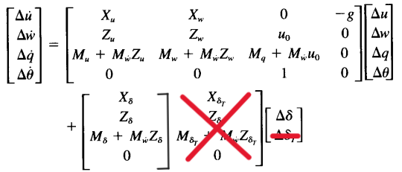

**Figure 1: Longitudinal Linearized Equation of Motion in State Space Form - Nelson, 149**

***In our case we neglect the second column of the B matrix, hence neglecting***

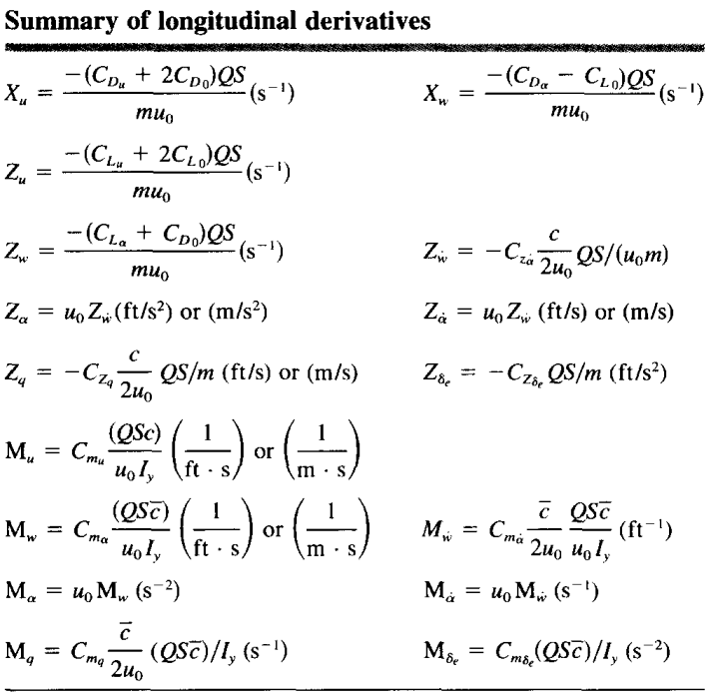

**Figure 2: Summary of Longitudinal Derivatives - Nelson, 123**

**Results**

Provided with the following aerodynamic data of the aircraft in **Figures 3/4**, I inputted these values into the longitudinal derivative equations from **Figure 2**.

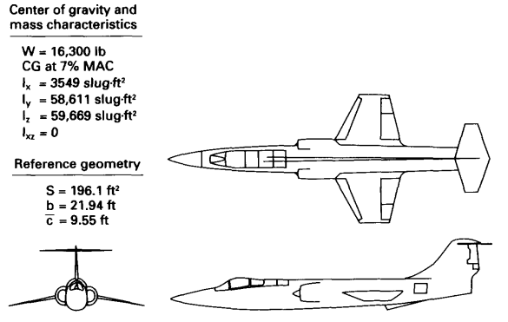

**Figure 3: Multi-View of Aircraft with specific characteristics**

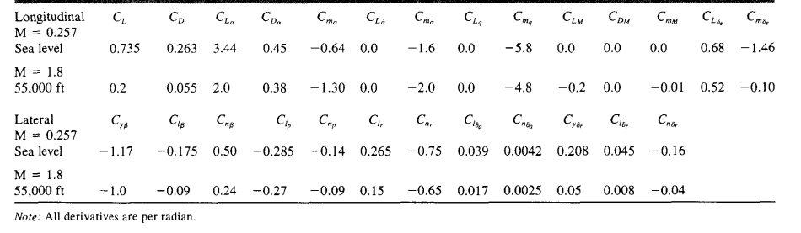

**Figure 4: Longitudinal and Lateral Stability Derivative Coefficients**

Using a script in MATLAB I determined longitudinal derivatives and inserted them in the **Longitudinal Linearized EOM in State Space Form**. From here I found the A and B matrices as the following:

**(A)** Matrix **(B)** Matrix

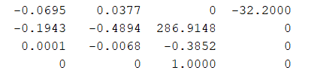 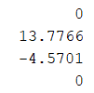

With the A matrix we can determine the eigenvalues which provides us the roots of the characteristic equation, from which we are able to acquire the Modal Characteristics and Time Reponses, and therefore the Handling Qualities of the aircraft.

**Discussion**

Modal Characteristics

The matrices calculated above were used to calculate several aircraft characteristics. Firstly, we calculated the eigenvalues of our **(A) Matrix**, by hand we could’ve used **Equation (1)** to find the roots, but instead, on MATLAB we are able to simply use the eig() function to find our eigenvalues of the **(A) Matrix** as the following:

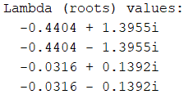

**Figure 5: Eigenvalues of Longitudinal EOM (A) Matrix**

With our root values I was able to conclude the aircraft is dynamically stable since the real part of each of our roots is negative. I was also able to determine the short period and phugoid mode roots, and with this, each modes modal characteristics. Since (the short period mode damping frequency must be larger than the phugoid period mode damping frequency) I confirmed -0.4404 +/- 1.3955i is the short period mode roots and the latter is phugoid mode.

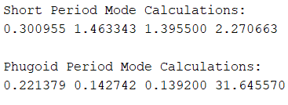

**Figure 6: Modal Characteristics of the Aircraft**

**Figure 6** displays the damping ratio, natural frequency, damping frequency, and time constant respectively for each Longitudinal mode. To determine each of these values I used **Equations (2), (3), (4).**

These values are important as they explain how the aircraft returns to equilibrium after a disturbance. From these values, as mentioned earlier, I’ve confirmed the aircraft is stable since each of the real parts of the roots are negative values. Since our damping ratio ( is less than 1, our system is underdamped, to ensure positive stability, the following must hold true 0 < < 1, and by our calculations we’ve met this criterion, again proving the aircraft is dynamically stable. Finally, our imaginary part, b, which is equivalent to the damping frequency, , determines whether the aircraft will oscillate when stabilizing. Since b is non-zero, the aircraft will oscillate. The short period mode always has a higher frequency of oscillation before reaching equilibrium compared to the phugoid period mode. We know there will be some oscillation when the aircraft is returning to equilibrium.

Reduced Order Analysis

To double check previous calculations in **Figure 6**, I will analyze the motion approximations for Short Period and Phugoid mode to ensure the values come close to my previous calculations.



**Figure 10: Short Period Mode of Motion Approximation – Nelson, 154**

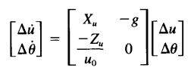

**Figure 11: Phugoid Period Mode of Motion Approximation – Nelson, 153**

With the approximations shown above in **Figures 10/11** I use the same values calculated from **Figure 3/4** to approximate the modal characteristics. The results are given in **Figure 12**.

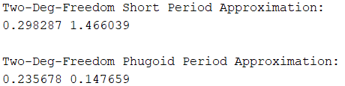

**Figure 12: Longitudinal Mode of Motion Approximation Results**

By my results I can confirm the original modal characteristic values are adequate, and the experiment may continue.

Time Responses

To visualize the oscillation, I have created time response graphs based on two scenarios. Firstly, we see in **Figure 7** the time response provided there is no elevator input, and with an initial condition (initial condition ).

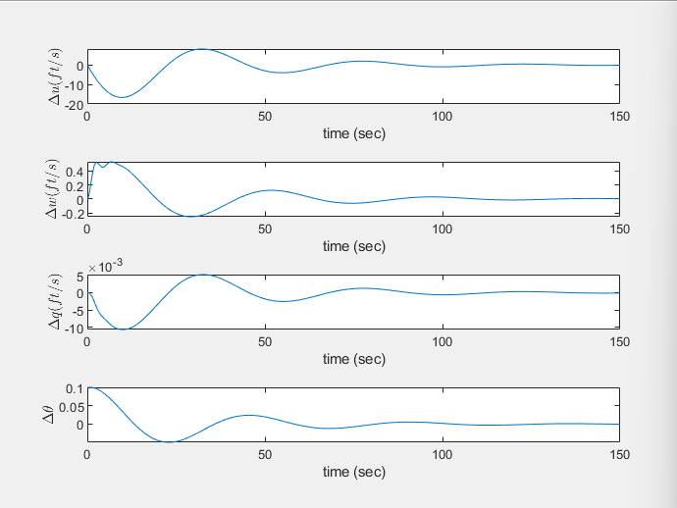

**Figure 7: Time Response, zero input, initial condition**

= velocity in x-direction

= velocity in z-direction

= pitch rate

= pitch angle

**Figure 7** shows the short-period mode as a fast, highly damped oscillation, settling within seconds, while the phugoid mode appears as a slow, lightly damped oscillation, lasting much longer. In this graph we see each component returns to steady state at 0.

The second scenario portrayed in **Figure 8** is the time response of our aircraft given no initial conditions, but now with a unit step input of elevator deflection, .

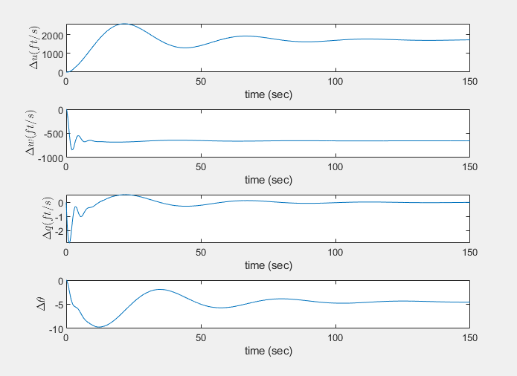

**Figure 8: Time response, unit step , zero initial conditions**

From the time response graph, we can see with a unit step input, as the variables return to steady state, only reaches 0 as the others converge to different values. In the zero input response, the modes naturally emerge, with the short-period mode fading quickly and the phugoid mode persisting. Under a unit step input, the short-period mode dominates the initial response, while the phugoid mode affects the long-term behavior.

Handling Qualities Investigation

Along with the time response graph, our modal characteristics can provide us with more information on our aircraft. Using the values I found in **Figure 6 (modal characteristics)** and the following tables I was able to determine the longitudinal flying qualities.

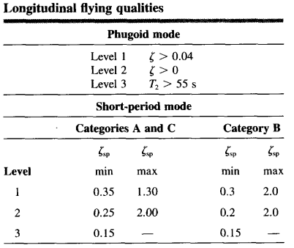

**Figure 9: Longitudinal Flying Qualities – Nelson, 167**

From these tables, I determined my data displays qualities of a Class IV, Category B, Level 1 aircraft. Class IV identifies high-maneuverability airplanes, such as fighter aircrafts. Category B describes our aircraft as being in a nonterminal (not taking off or landing) flight phase that does not require rapid maneuvering, but rather gradual maneuvers to accomplish its mission flight phase. Finally, Level 1 describes our aircraft flying qualities are adequate for the mission flight phase. Level 1 is the most optimal flying quality as it doesn’t require excessive pilot workload and should not have any degradation in mission effectiveness.

**Conclusion**

Through this experiment, I analyzed the longitudinal stability and dynamic response of an aircraft using wind tunnel data and stability derivatives. By computing the eigenvalues of the system, I confirmed that the aircraft is dynamically stable, with a well-damped short-period mode and a lightly damped phugoid mode. The time response analysis demonstrated the distinct characteristics of each mode, where the short-period mode settles quickly, while the phugoid mode exhibits prolonged oscillations. Based on the handling quality criteria, the aircraft falls under Class IV, Category B, Level 1, indicating it is well-suited for nonterminal flight with minimal pilot workload.

**Appendix**

MATLAB code along with some raw calculations



